TRAVELLING SALESMAN PROBLEM

AIM: To write a python program for Travelling Salesman Problem.

OBJECTIVES:
- To understand the Travelling Salesman Problem.
- To calculate the minimum cost path among a set of cities.
- To learn the concept of optimization in Artificial Intelligence.

ALGORITHM:
- Start the program.
- Store the distance between every pair of cities in a matrix.
- Assume the first city as the starting city.
- Visit the nearest unvisited city.
- Repeat until all cities are visited.
- Return to the starting city.
- Calculate and display the total travel cost.
- Stop the program.
SYSTEM ARCHITECTURE:
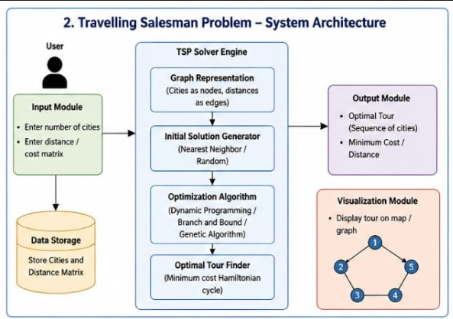
PROGRAM:
cost = [[0,10,15,20],
[10,0,35,25],
[15,35,0,30],
[20,25,30,0]]

visit = [0]
total = 0

while len(visit) < 4:
last = visit[-1]
m = 999
for i in range(4):
if i not in visit and cost[last][i] < m:
m = cost[last][i]
city = i
visit.append(city)
total += m

total += cost[visit[-1]][0]

print("Path:", visit + [0])
print("Minimum Cost:", total)

OUTPUT:
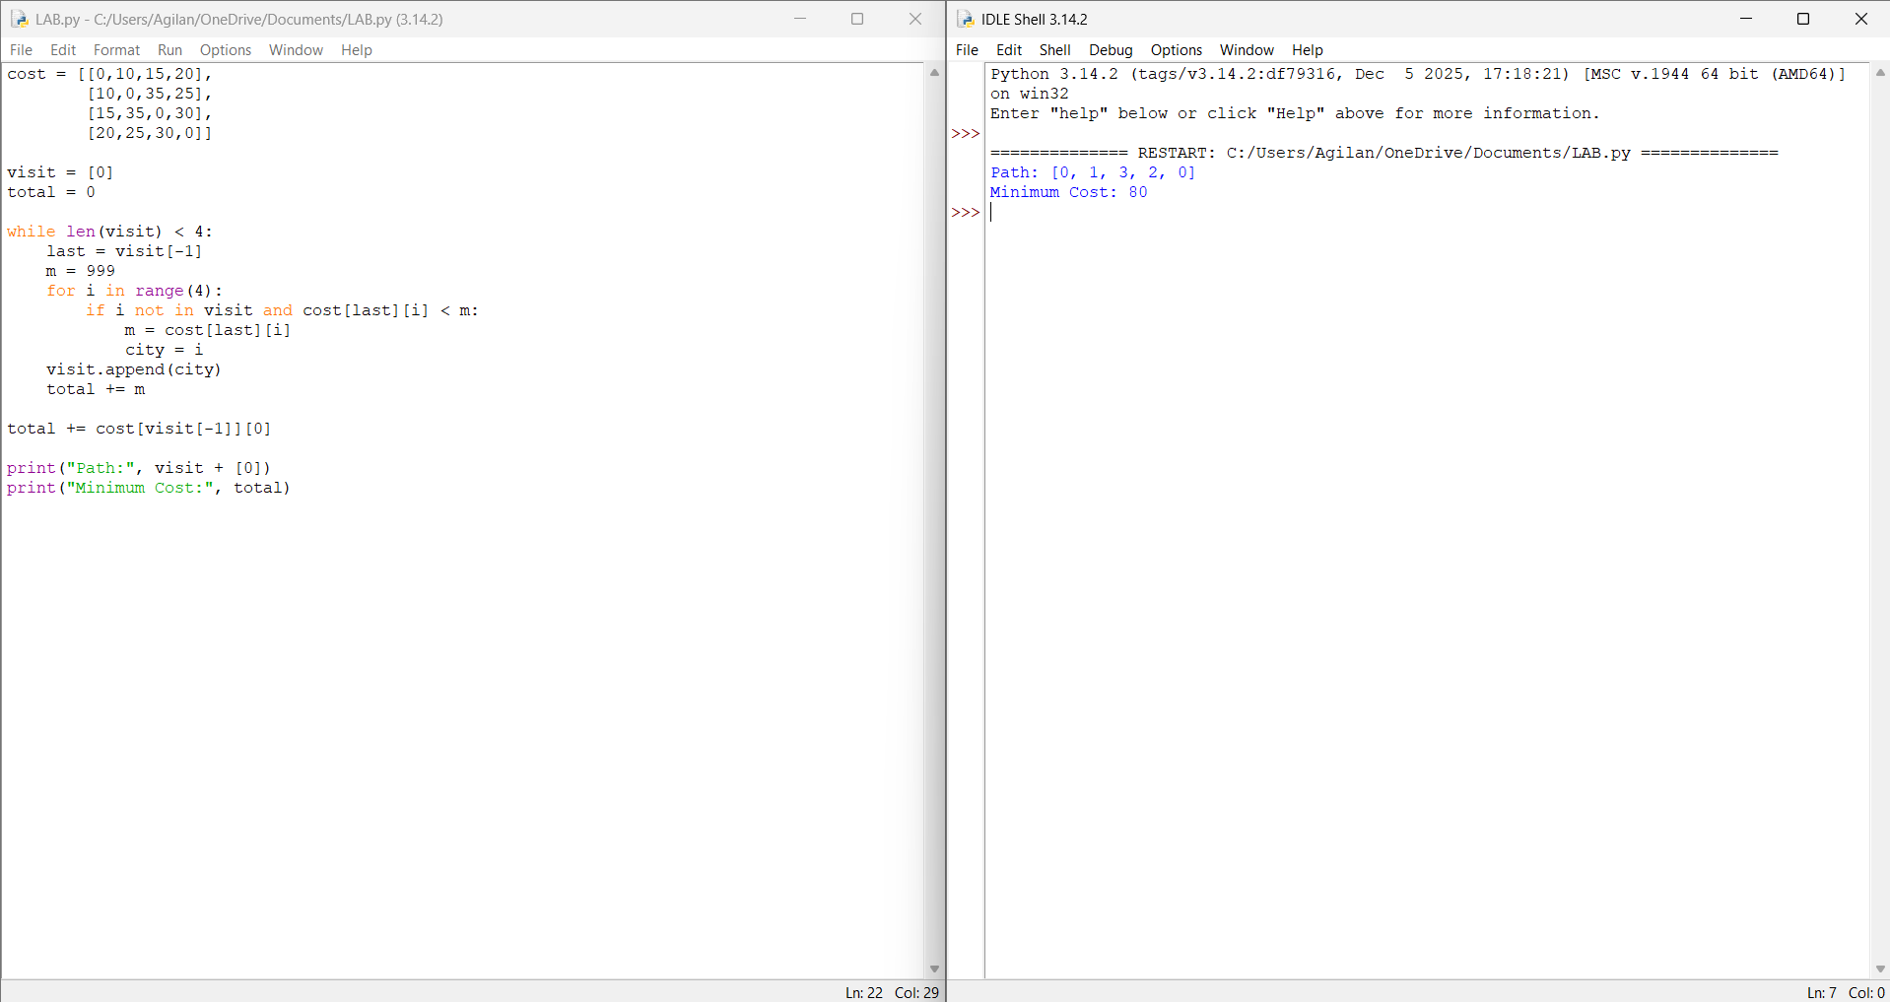

RESULT: Thus the Travelling Salesman Problem is implemented successfully using python language.

